Ecosystem services: The Case of Mau Forest and Yala Swamp

An Assignment submitted in partial fulfillment of the requirements for the degree of
Bachelor of Science
in
Computer Science

ENVS 1301: Introduction to Environmental Sciences
Term 3 - 2025
University of The People
February 20, 2024

Ecosystem services: The Case of Mau Forest and Yala Swamp
Introduction
An ecosystem is a community of animals and plants interacting with one another and their physical environment. Ecosystems include physical and chemical components, such as soils, water, and nutrients that support the organisms living within them (Ecological Society of America, 2012). On the other hand, ecosystem Services refer to the processes by which the environment produces resources that we often take for granted, such as clean water, timber, habitat for fisheries, and pollination of native and agricultural plants (Ecological Society of America, 2012). This essay will explore the ecosystem services provided by the Mau Forest and the Yala Swamp in Kenya. Moreover, the essay will also explore how the exploitation of these two ecosystems endangers biodiversity and actions that people could take to help protect the services each provides to the Kenyan citizens.
The Mau Forest in Kenya
The glorified Mau Forest before exploitation | The displeasing Mau Forest today
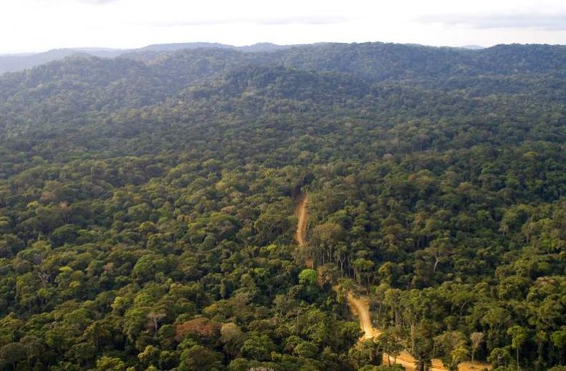 | 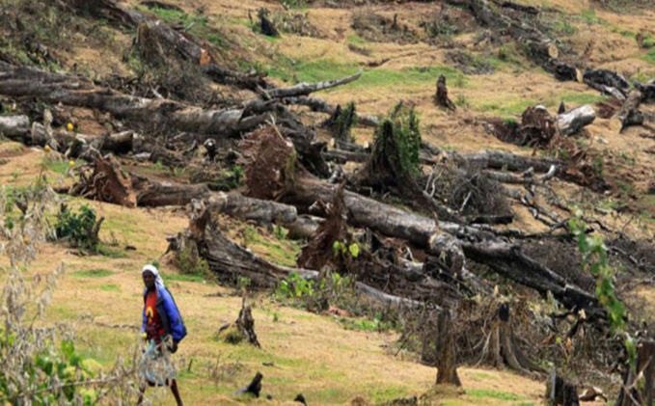

The Mau Forest provides various ecosystem services, including timber, which is an essential resource for the local community. Timber is harvested from the forest, supporting the livelihoods of many people in the area. However, the deforestation process in the Mau Forest is threatening the availability of timber as an ecosystem service. According to Albertazzi et al. (2018), the forest has lost about a quarter of its area in the last twenty years, leading to a decrease in timber production.
The loss of timber as an ecosystem service will have significant economic costs to society. The Mau Forest plays a crucial role in the agricultural, tourism, and energy sectors, and the loss of timber will impact these industries. Additionally, the forest provides habitat for various species, including the African golden cat and the yellow-backed duiker, which are vulnerable to extinction due to habitat loss. The loss of these species will have long-term consequences for the ecosystem, leading to a decline in biodiversity and ecosystem resilience (Albertazzi et al., 2018). To protect these services, one action that people could take is to support sustainable forest management practices, such as reforestation and agroforestry, which can help maintain the health and productivity of the forest while also providing economic benefits to local communities.
The Yala Swamp
The glorified Yala Swamp before exploitation | The deplorable Yala Swamp today
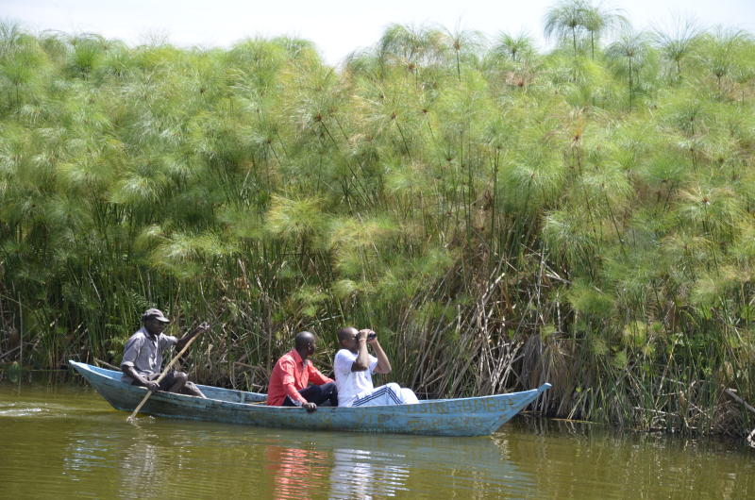 | 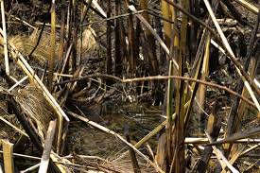

The Yala Swamp provides several ecosystem services, including water regulation and filtration. The swamp acts as a natural filter, purifying water from the Yala River as it flows into Lake Victoria. This process helps maintain the water quality in the lake, supporting the diverse aquatic life that inhabits it. The swamp also regulates the water flow, absorbing significant amounts of carbon and storing and releasing vast amounts of rainwater, which helps reduce the impacts of floods (BirdLife International, 2023). These ecosystem services are endangered due to the proposed development of a sugarcane plantation in the swamp. The destruction of the habitat will clear much of the swamp's natural filtering system, leading to a decrease in water quality and increased flooding risks. This, in turn, will have economic costs to society, including damage to infrastructure, loss of livelihoods, and increased healthcare costs due to water-borne diseases. According to BirdLife International (2023), the loss of ecosystem services such as water filtration and regulation can have significant economic costs, including damage to infrastructure, loss of livelihoods, and increased healthcare costs.
One action that people can take to help protect these services is to support conservation efforts and raise awareness about the importance of the Yala Swamp. By signing the online petition and sharing information about the issue, individuals can contribute to the international campaign to save the swamp. This can help put pressure on the Kenyan government to reconsider the proposed development and prioritize the conservation of the swamp (BirdLife International, 2023). Furthermore, supporting organizations such as Nature Kenya can help amplify the voices of local communities and stakeholders who are fighting to protect the swamp. Moreover,
supporting organizations such as Nature Kenya can also help provide alternative livelihoods for local communities, reducing their reliance on the swamp for food and income (BirdLife International, 2023). This can help mitigate the economic costs associated with the loss of ecosystem services and ensure that the benefits of conservation are shared equitably among all stakeholders. Supporting conservation efforts can protect the Yala Swamp and its ecosystem services, ensuring a sustainable future.
Conclusion
This essay explored the ecosystem services provided by the Mau Forest and the Yala Swamp in Kenya, highlighting the risks posed by their exploitation. The Mau Forest offers essential resources like timber, but deforestation has led to significant habitat and biodiversity loss. Similarly, the Yala Swamp's natural water purification and regulation services are threatened by proposed developments. Sustainable management practices and conservation efforts are crucial to protect these ecosystems. By supporting these initiatives, the local community will be guaranteed an unlimited provision of vital ecosystem services, safeguarding both the environment and their well-being.

References
Albertazzi, S., Bini, V., Lindon, A., & Trivellini, G. (2018). Relations of power driving tropical deforestation: A case study from the Mau forest (Kenya). Belgeo, (2). https://doi.org/10.4000/belgeo.24223
BirdLife International. (2023, June 2). Irreplaceable: Kenya’s Yala swamp complex. https://www.birdlife.org/news/2023/05/30/irreplaceable-kenyas-yala-swamp-complex/
Ecological Society of America. (2012). Ecosystem services. https://www.esa.org/esa/wp-content/uploads/2012/12/ecosystemservices.pdf

